Python Programming Lab Task Sets

Set 5
- Q1. Generate Python code for the Fibonacci sequence with Cursor AI. Refine your prompts to handle only positive integers and record the changes and outcomes.
prompt
Generate Python code for the Fibonacci sequence with Cursor AI. Refine your prompts to handle only positive integers and record the changes and outcomes.
GIVE SINGLE ANSWER and single code
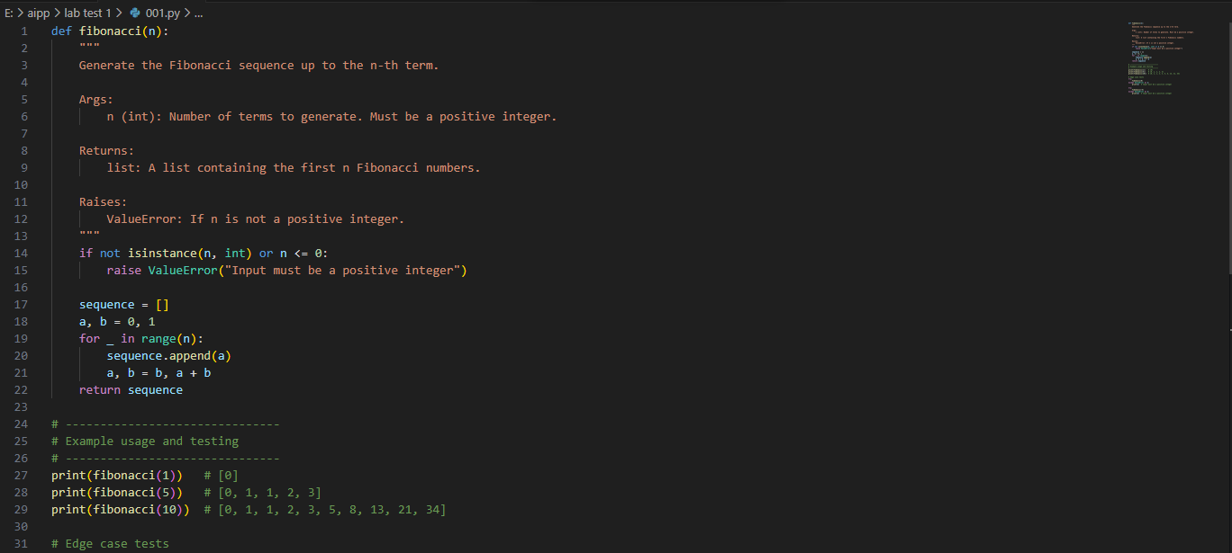
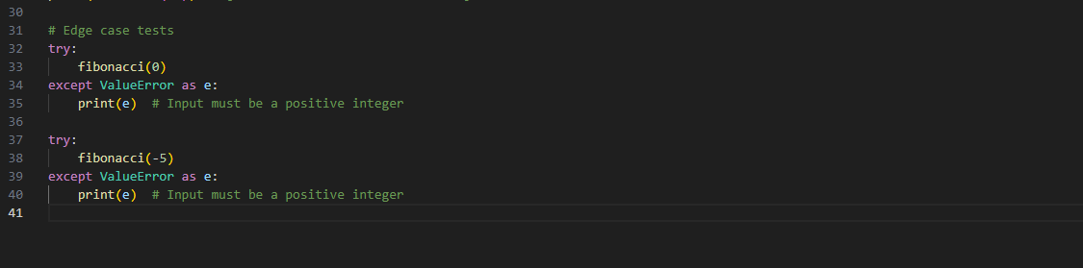
result
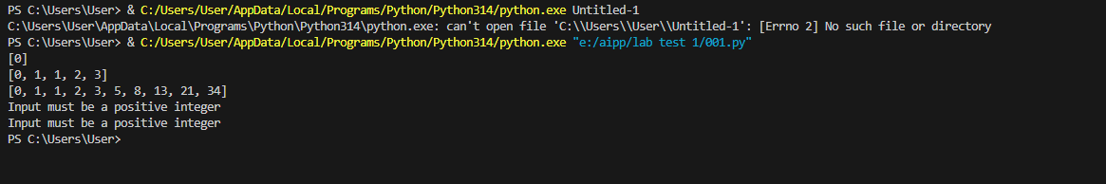
(Each question carries 5 marks)
- Q2. Write a Python queue class (`enqueue`, `dequeue`, `peek`). Use an AI assistant and test the class with multiple scenarios. Describe how AI-generated code manages edge cases and how you improved it.
prompt
Write a Python queue class (`enqueue`, `dequeue`, `peek`). Use an AI assistant and test the class with multiple scenarios. Describe how AI-generated code manages edge cases and how you improved it.
GIVE SINGLE ANSWER and single code
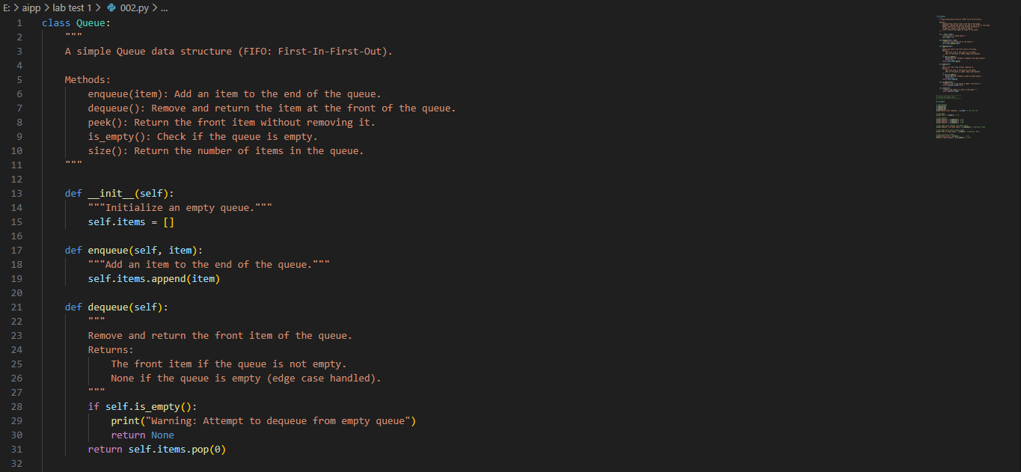
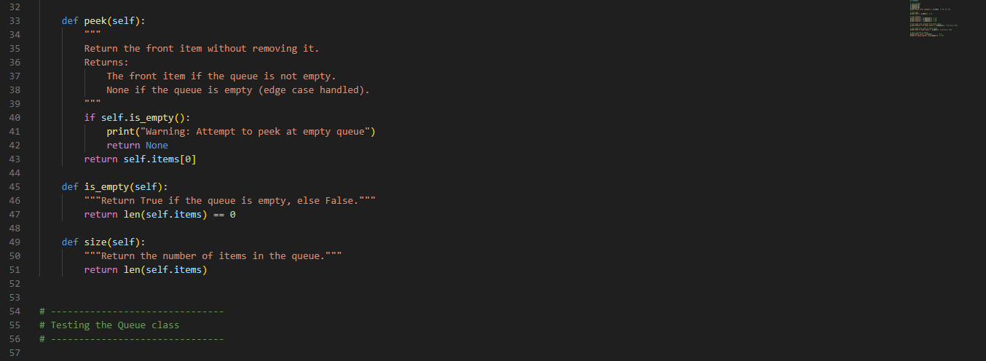
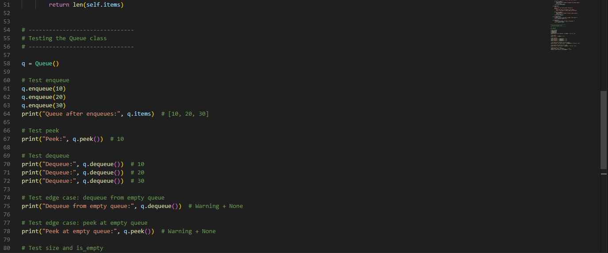
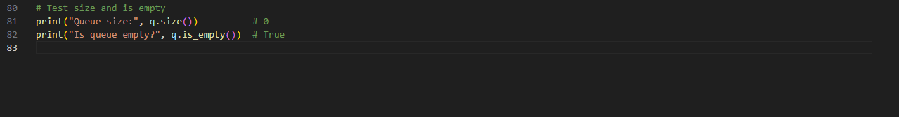
result
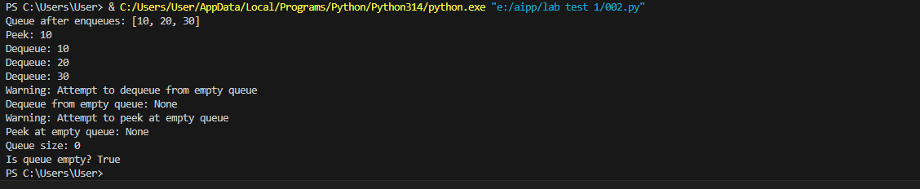
(Each question carries 5 marks)

